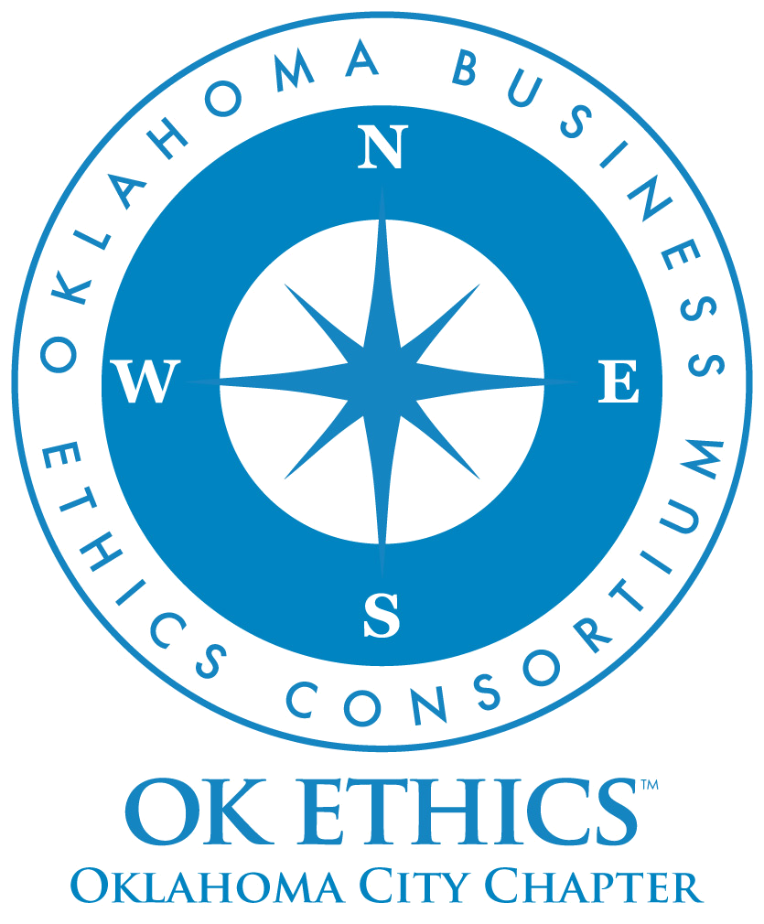
OKLAHOMA BUSINESS ETHICS CONSORTIUM
Oklahoma City Chapter ~ October 8, 2008

VISION: To be recognized as a statewide (and national)
forum for promoting business ethics.

- KUDOS & WELCOME Garyl Geist, President & CEO,Valir Health
President, OkEthics Board of Directors
  - Greg Byers of Sinclair Broadcasting Group – Epitomizing flexibility and a servant’s heart, we appreciate Greg’s ongoing leadership as Registration Chair.
  - Mary Kay Huggard & the Principal Technologies team consistently demonstrate a welcoming attitude and great service to all our members. Registration team members include: Lisa Laughlin, Rebecca Deal, Holly Carattini, Josie Strickland, Ashley Warne, and Jennifer Hicks.
  - Joshua Jantz of the Institute of Basic Life Principles inspires us with his humble servant’s heart. Thank you for working late to provide name tags each month.
  - Connie Barwick – Maximum Multi Media Creations for the pre-meeting Power Point presentations and website. A special welcome to Connie’s son: Private First Class Mike Barwick.
  - Bobby Redinger – Cole & Reed for her generosity in providing today’s agendas.
  - Alisa Hall – The Stiletto Advantage for her initiative in purchasing the speaker gifts each month.
  - Have you met Deborah Gavula, our new administrative support contact? She will be handling OkEthics billing and other administrative duties. Deborah can be reached at 889-0498.
  - Behind the scenes, our dedicated volunteers who serve on the Board and are the heart of this organization!

- BRING YOUR BOSS DAY! Garyl Geist, Valir Health
Introduction of special guests

- MEMBERSHIP DRIVE UPDATE Shannon Hiebert, Vice President, Enterprise Rent-A-Car
OkEthics Founding Member & Vice President of Membership

MANY THANKS TO THESE STEADFAST SPONSORS FOR
PROMOTING OKLAHOMA VALUES OF INTEGRITY AT WORK!

OkEthics has doubled commitments at the NAVIGATOR level ($7500)
 | 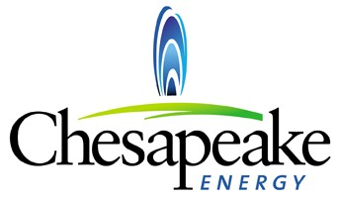 | 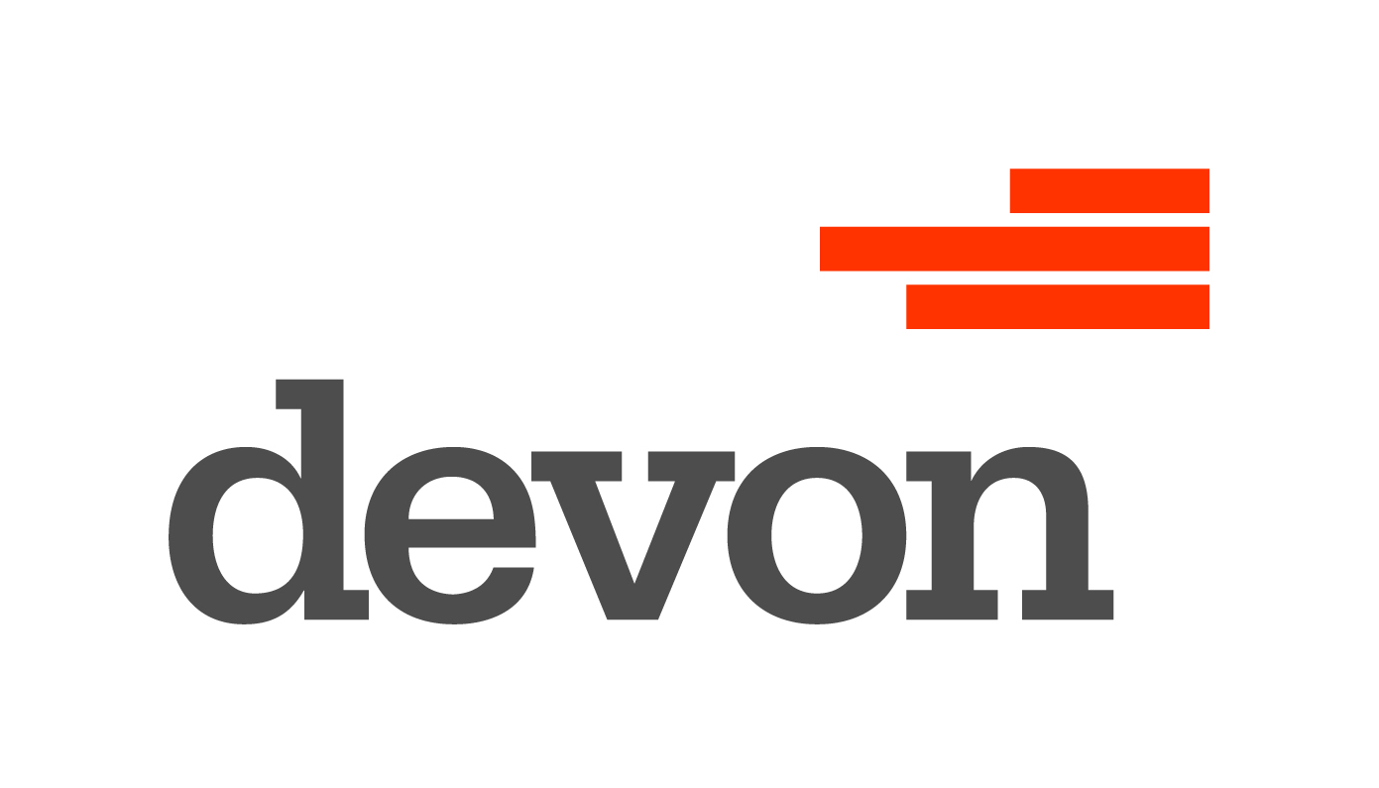 | 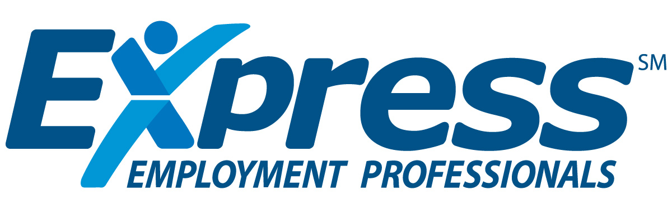
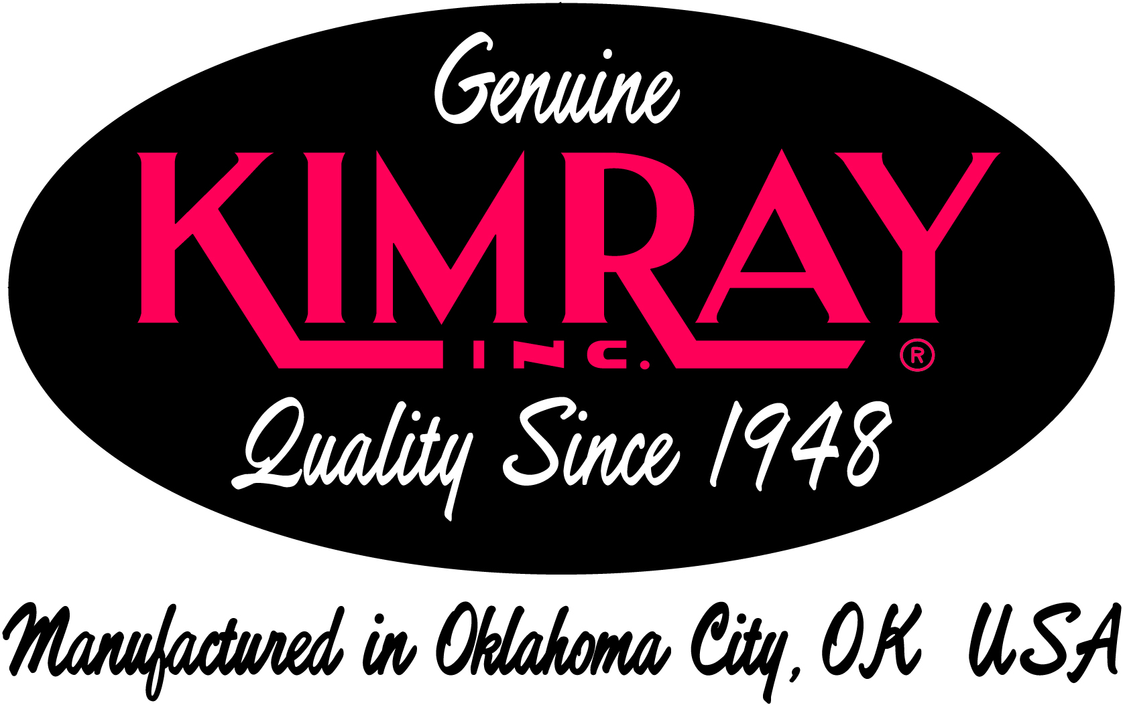 |  | 

BE THE DIFFERENCE: JOIN NOW!
WWW.OKETHICS.ORG
Oklahoma Star Level ($5000):
 | 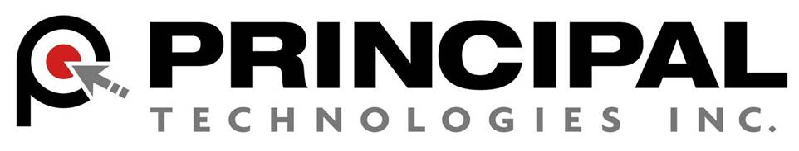 | 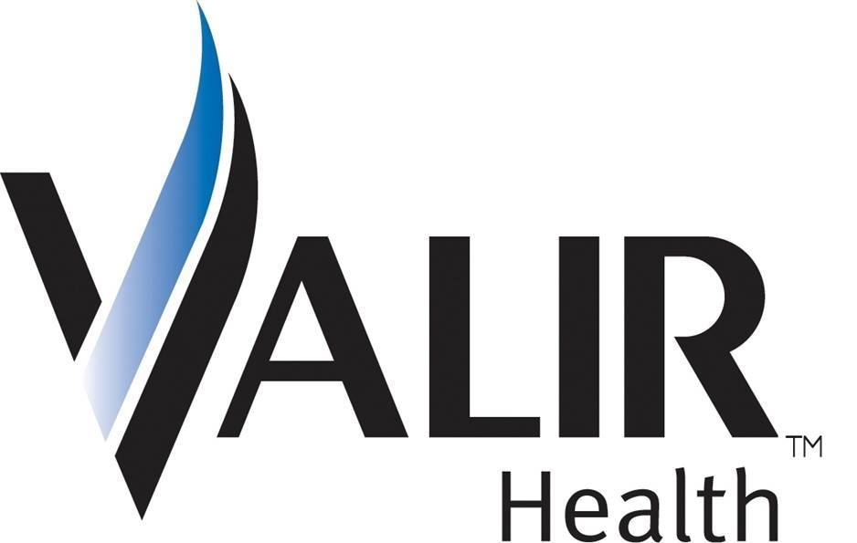

Horizon Level ($3000):
 | 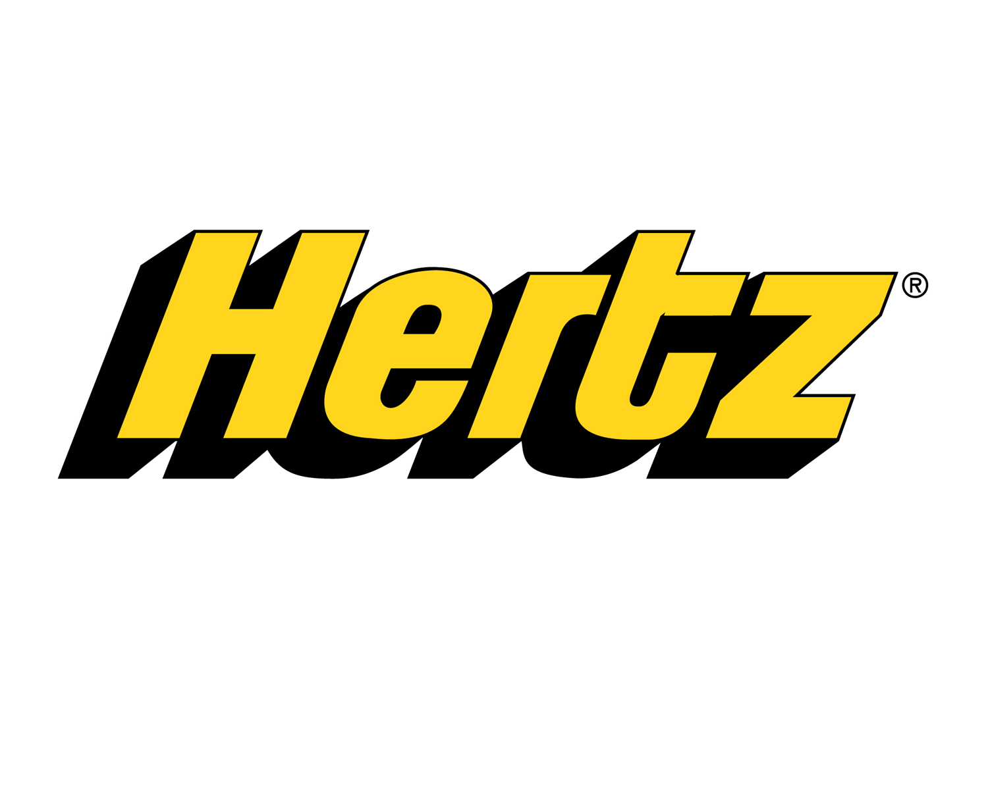 | 

IV. GUIDING PRINCIPLE
Responsibility to Self & Others:
Encouraging the promotion of ethical behavior through personal actions. Sharing ideas and resources

General Disclaimer: Members of the Oklahoma Business Ethics Consortium frequently share information concerning various issues and developments that may have legal implications. The discussions, commentary, and handouts at Consortium meetings or presentations to other organizations are for general informational purposes only. They cover only some aspects of the subject topic, and do not constitute a complete legal analysis of the topic or how it might apply to any particular set of facts. Before taking any action based on information presented during a Consortium event, participants are encouraged to consult a qualified attorney. The observations and comments of presenters at Consortium meetings and networking are the views and opinions of the presenter and do not constitute the opinion or policies of the Consortium or any of its members. Presenters are respectfully requested to avoid profanity, preaching, politics and self-promotion during their lectures. It is the responsibility of participants to demonstrate applicability of each program for demonstration of earned CPE credits, if applicable.

What happened on Wall Street? The film “Wall Street” dates back to 1987. Can you see any similarities between the fictional characters in the movie and what could happen in real life?

Discussion questions:
- What pressures do “regular people” face that might lead them into making unethical decisions in the workplace?
- Do you think that the recent events on Wall Street may have an impact on ethical behavior in your organization?
- How can each of us as individuals promote Oklahoma values of integrity at work?

See also the Guiding Principle of Respect:
Members may become aware of confidential information shared by others in an effort to determine an ethical course of action. We ask members to be sensitive in recognizing and respecting the efforts made toward achieving ethical behavior. In that vein, public disclosure of this information is discouraged.
V. Presentation: Kirk Humphreys, ‘’The Oklahoma Standard”
Introduction by Garyl Geist, President of OkEthics Board of Directors

VI. UPCOMING EVENTS Shannon Warren, Founder, OkEthics
Advance reservations required for all events ~
Visit our website at www.okethics.org or call 858-2233;
Member discounts apply regardless of location.
Moore-Norman- South OKC:
November 19 – Brian Gabbard, CEO of Gabbard & Company;
“Managing Change Through a Downturn”

OKC Chapter

November 12 – Sam Presti, General Manager, OKC Thunder
December 10 – Medical CEO Panel

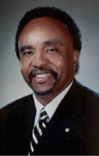
March 11 – Clifton Taulbert, President of The Building Community Institute
Taulbert is one of America's leading thought-leaders on the "Power of Community" and views community in the workplace as a powerful leadership asset. Taulbert was chosen by CNN at the turn of the millennium to represent one of the voices of 'Community.' Taulbert, a Pulitzer nominated author speaks throughout the world on the critical issue of building community, a set of emotionally satisfying relationships, within all the places of our living...creating an environment branded by Respect, Affirmation and Inclusion.

Taulbert is also the author of the internationally acclaimed book, Eight Habits of the Heart, a book that provides the framework on which to build, maintain and sustain a powerful, effective and caring Community. He believes the Eight Habits of the Heart are essential for developing leadership and he conveys this message to audiences around the world.
April 29 – OU Coach, Sherri Coale –
OkEthics Statewide Compass Awards (OKC)

Tulsa Chapter

October 23 – Dr. Gary Namie, “ The Workplace Doctor” and expert on workplace bullying

November 20 – “Crisis Communication: The Ethics of Conflicting Voices” - A four-member panel representing the fields of law, media, litigation communication, and PR will lead us through two crisis case studies. We will explore the ethics of communication decisions and the pressures a business owner/leader faces (and the counsel he/she receives) from multiple perspectives during a crisis.

- OTHER RELATED PROGRAMS:

Oklahoma City Business and Community Leaders' Luncheon

Character First Institute - Tuesday, October 28 (7:00 to 8:00 a.m.)
or Thursday, October 30 (Noon to 1:00)

Registration Information: Call 815-0001, or visit www.characterok.org. Program focus on “Gratitude”

For more events and information about OkEthics, please visit our website at www.okethics.org
See also additional sponsors listed on our website.
PLEASE HELP US CONTROL COSTS BY LEAVING YOUR NAME TAG HERE!
Oklahoma Business Ethics Consortium
Guiding Principles

To ensure that the Consortium fosters positive characteristics of integrity in the successful achievement of its goals, these Guiding Principles were discussed and adopted (with revisions) during a milestone planning session held by Consortium leaders in Stroud on June 18, 2004. These are heavily guided by the Character First Institute’s values and philosophies.

I. Responsibility to Self and Others:
- Service:
  - Passion for promoting ethics and integrity
  - Encouraging the promotion of ethical behavior through personal actions and
  - Sharing ideas and resources
  - Responsibility and accountability for fulfilling the mission of the Consortium.
- Collaboration:
  - Achievement of common goals through the promotion of ethical, mutually beneficial relationships
  - Service to the Consortium over promotion of self-interest
  - Cooperation emphasized over competition in promoting ethical business conduct
  - Members collaborate by being constructively engaged in discussions regarding ethics
  - Seeking consensus in interactive discussions regarding ethical matters.
- Respect:
  - Members may become aware of confidential information shared by others in an effort to determine an ethical course of action. We ask members to be sensitive in recognizing and respecting the efforts made toward achieving ethical behavior. In that vein, public disclosure of this information is discouraged.
  - We respect other members and the process by:
    - Exhibiting listening skills and actively listening to discussions
    - Being open to other points of view and outcomes
  - We are an inclusive organization and demonstrate this by welcoming members who are in different stages of learning as applied to ethical behavior.
II. Lead with Integrity
- Dependability:
  - Members are asked to demonstrate their support of this initiative by consistently attending meetings.
- Initiative:
  - Recruiting other members who have demonstrated a desire to promote ethical behavior in their organizations.
  - Recognizing what needs to be done to help promote the Mission of the Consortium and taking action to assist in that effort.
- Honor:
  - Members are asked to honor the Consortium through the practice of integrity and ethical behavior in their business dealings.
  - We express gratefulness to our hosts, sponsors and speakers.
  - Realizing that each of us is in a mode of continual learning, we demonstrate humility, care and compassion when sharing our thoughts and knowledge.
- Courage:
  - Speak the truth with confidence and encourage others to do the same.

